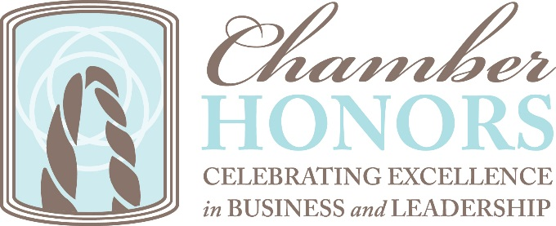

Outstanding Volunteer History

2018 John Regal, Securian Financial
2017 Doug Hennes, University of St. Thomas
2016 Terri Banaszewski, Sunrise Banks
2015 Joan Siewert-Cardona, Ideal Printers
2014 Kris Taylor, Ecolab
2013 John Marshall, Xcel Energy
2012 Tony Schwartz, Cormarq
2010 Susan Kratz, Moore Costello & Hart, P.L.L.P.
2009 Bonnie Holub, Adventium Labs
2008 No award given (switch from giving award at Annual Meeting to Gala)
2007 Rick Beeson, Park Midway Bank
2006 Annette Lee, Mintahoe Hospitality Companies
2005 Don Maietta, Coldwell Banker Burnet
2004 Frank Caulfield, Lee F. Murphy Insurance
2003 Betsy Bockstruck, Bockstruck Jewelers
2002 Dan Foote, Foote&Co.
2001 Tim Marx, Briggs & Morgan, P.A.
2000 Tanya Bell, Wellington Management
1999 Mary Schmitz, Jeane Thorne
1998 Richard Hanson, 3M
1997 Dwayne Radel, Minnesota Life
1996 Margaret Hennen, Unisys

Emerging Volunteer History

2018 Amanda Knutson, HealthEast, a part of Fairview Health Services
2017 Rachael Reiling, SPIRE Credit Union
2016 Sara Thatcher, Goff Public
2015 Jim Mulrooney, Wells Fargo
2014 Gregg Cummings, Morgan Stanley Wealth Management
2013 Shelly Dailey, Brandography
2012 Ingrid Christensen, INGCO
2011 Ryan Rutzick, All Inc.
2010 Zach Crain, Moore Costello & Hart P.L.L.P.
2009 Justin Bieganek
2008 Elizabeth Sorensen

